**Lab-Project 10: Attacking Apache with the OWASP HTTP DoS Tool**

**Starting the Apache Web Server**

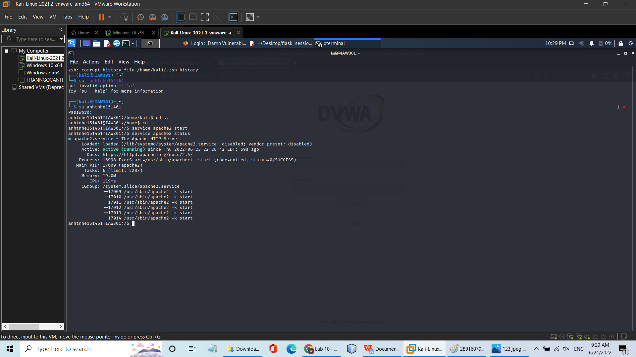

**Viewing the Apache Server Status**

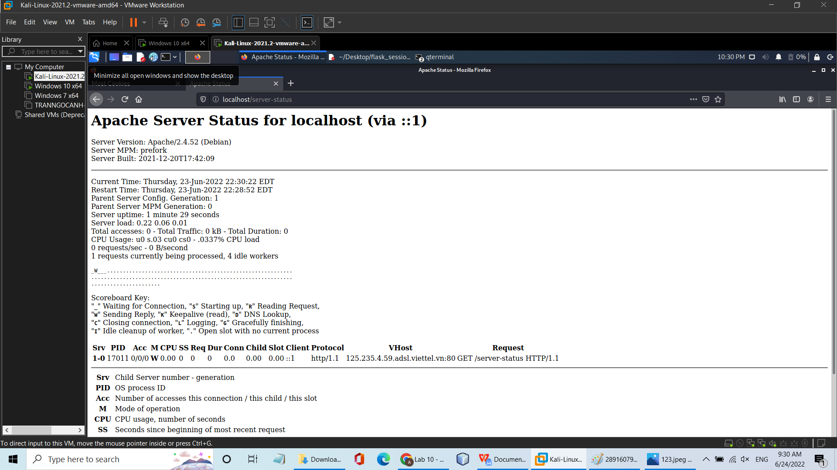

**Attacking Apache with the OWASP HTTP DoS Tool**

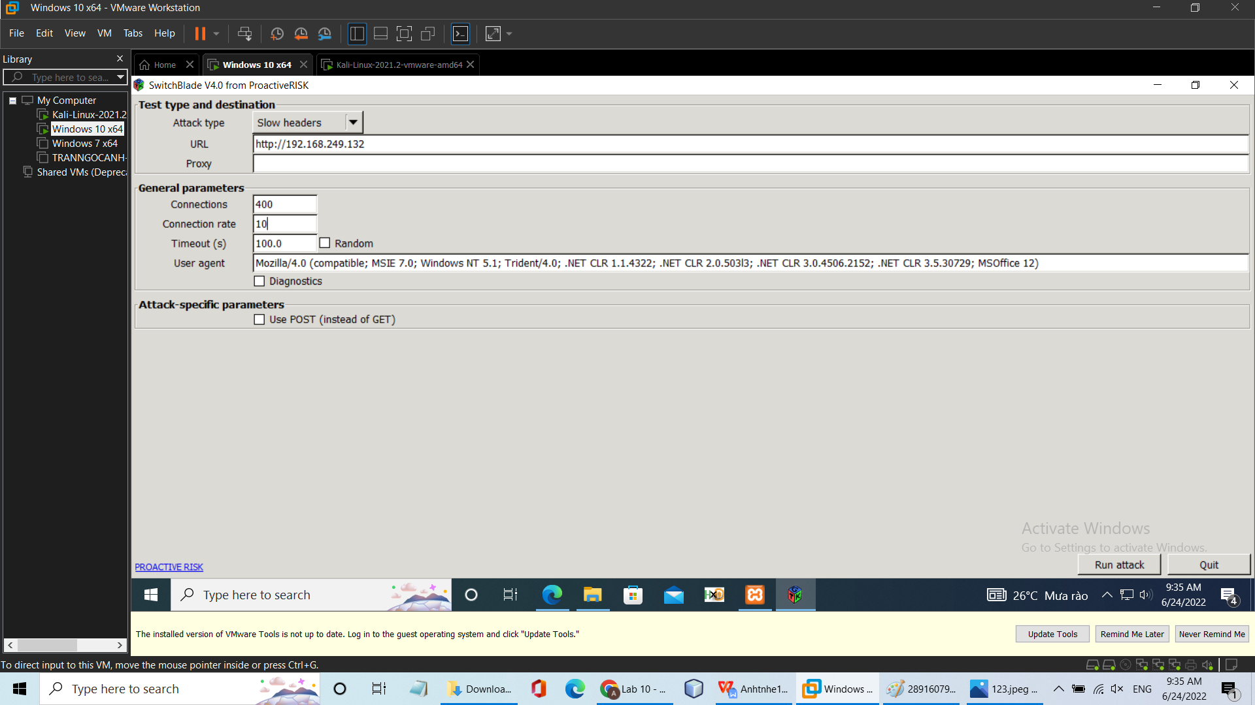

**Viewing the Apache Server Status**

